**Programme of Concerts**

**2025 – 2026**

**Programmes subject to alteration at the artistes' discretion**

**Saturday 27th September 2025**

* **Dick Lee & Anne Evans**

*Venue –Hawick Rugby Football Clubrooms at 7pm*

To start the Club’s 74th season, Dick and Anne are making a welcome return, having last performed for us in 2018.

Playing piano, flute, clarinet, and saxophone we are assured a vibrant evening’s entertainment with pieces from -

* *Van Heusen / Burke - Aren’t You Glad You’re You*
* *Debussy – Arabesque*
* *Milhaud – Scaramouche: II. Modere III. Brasileira*
* *Scott Skinner – Cradle Song*
* *Joplin – The Entertainer*
* *Dick Lee – Filippo 70*

**Saturday 18th October**

* **The Robin Chapel Lay Clerks Singers**

*Venue – Hawick South Church Buccleuch Road Halls at 7pm*

Robin Chapel Lay Clerks are a professional choir of 8 voices founded originally to sing in Robin Chapel in Edinburgh. The Chapel is inter-denominational and the Lay Clerks sing a weekly service as well as giving concerts and singing in other churches and cathedrals. This special concert will be their first performance in the Borders.

**Sunday 23rd November**

* **Andrew Liddell & Daniella Nasar**

*Venue - Hawick South Church Buccleuch Road Halls at 3pm*

Andrew Liddell is an artist in residence of the composition department at Trinity Laban Conservatoire in London. He has performed in venues ranging from Ronnie Scott’s and the Cavern Club in Liverpool to Symphony Hall Birmingham and this year will perform in Edinburgh Fringe Festival and Lilliesleaf Festival. The programme includes –

* *Wienawski Legende*
* *Beethoven Sonata 10*
* *Prokofiev Sonata 1*
* *Shostakovich Gadfly*

**Sunday 18th January 2026**

* **The Troppos Quartet**

*Venue – Hawick South Church Buccleuch Road Halls at 3pm*

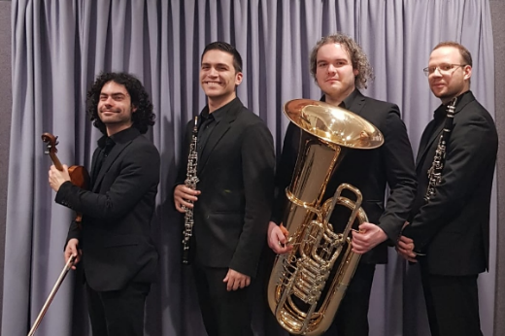

This quartet play violin, oboe, clarinet and tuba and their programme includes -

* *Tea for Two - Dmitri Shostakovich*
* *Erbarme Dich, mein Gott -  J S Bach*
* *España Cañí - Pascual Marquina*
* *Sleeping Beauty Op 66 Waltz - Pyotr Tchaikovsky*
* *Underground Tango - Goran Bregovic*

**Saturday 21st February**

* **Meraki Duo**

*Venue – Hawick South Church Buccleuch Road Halls at 7pm*

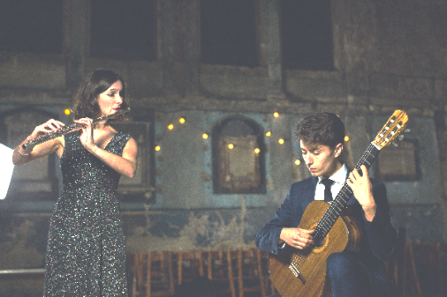

Performing flute and guitar works from their debut album, there will be music from France, the U.S., Trinidad, Japan, Serbia/Macedonia and Scotland!

'Wordless songs’ is the thread through the album. Pieces include -

* *Olivier Messiaen, arr. Girling - 5 Leçons de solfège*
* *William Grant Still, arr. Girling - Three Songs*
* *Dominique Le Gendre, arr. Girling - selections from Songs and Dances of the Islands Suite*
* *Miroslav Tadić - Four Macedonian Pieces*
* *Tōru Takemitsu - Toward The Sea*

**Sunday 29th March**

* **Viktor Mastoridis**

*Venue – Hawick Rugby Football Clubrooms at 3pm*

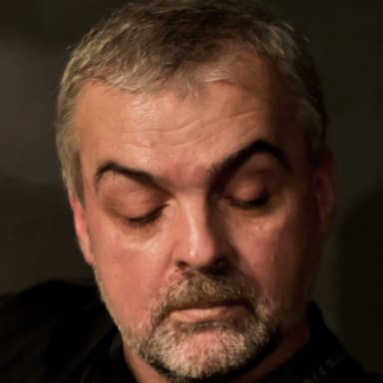

Viktor is a composer of music ranging from Rock and Hip-hop in ex-Yugoslavia to Greek & Balkan Neo-Folk and Blues Fusion in London, UK.

He sings and plays the guitar, bouzouki, bass, baglamas and tambura.

This promises to be a fun-filled, toe-tapping afternoon of entertainment.

Annual Membership gives members

a very generous discount on entry to all six concerts in the programme.

Adults £70

Contact Membership Secretary:

Mrs Muriel Wilson

Main Street

Denholm, Hawick TD9 8NU

Telephone 01450 870514

or E-mail: [ticketsHMC@outlook.com](mailto:ticketsHMC@outlook.com)

Non-members are always welcome.

Entry to each concert costs £15

and is free for accompanied people under 18 years.

Book to attend any concert by contacting Muriel Wilson [ticketsHMC@outlook.com](mailto:ticketsHMC@outlook.com)

**Hawick Music Club**

was formed in 1951

with the aim of promoting

and encouraging music

in all its different forms.

Charitable status

was granted in 1983.

The Club now celebrates

the 74th Season

of live concerts in the town

and has contracted a wide variety

of musicians to perform.

Performers, dates and venues

are listed overleaf.

Visit us online at

[www.hawickmusicclub.com](http://www.hawickmusicclub.com)

Hawick Music Club

is a founder member of

Scottish Consortium of Music Societies

Bringing live music

to Teviotdale

Season 74

**2025 – 2026**

**Celebrating the Centenary**

**of local composer**

**Brian Bonsor**

**whose published music is performed worldwide.**

**He was a founder member of Hawick Music Club.**

Charity # SC008473